|  |  |  |
| --- | --- | --- |
| Project Settings: <https://drive.google.com/open?id=1bIWSzxDlhNRyUOUX_9wq728ZlzKtD0T2mv1hEl6MYnA>  Please view project settings before start | | |

1. **Task Requirement / Description**
2. **Navigate to Task Area**
3. **UI Example**
4. **Programming Logic**
5. **Database**
6. **Changes to Commit ( developer to complete )**
   1. **Files / Folders to add to live site**
   2. **Database Changes to add to live site**
   3. **Developer notes / instructions for Project Manager**

**1. Task Requirement / Description**

Customer requires images to be changed over and repositioned.

Please replace the 2nd and 3rd banner images with the ones from this folder:

<https://drive.google.com/open?id=0B6m_jUysn34dX1dIODh1Zi1yUUU>

They have a different size canvas in the background.

Please center the images vertically so when full screen the top of the products is touching the menu and the bottom of products is touching the footer.

**2. Navigate to Task Area**

Front index page

**3. UI Example**

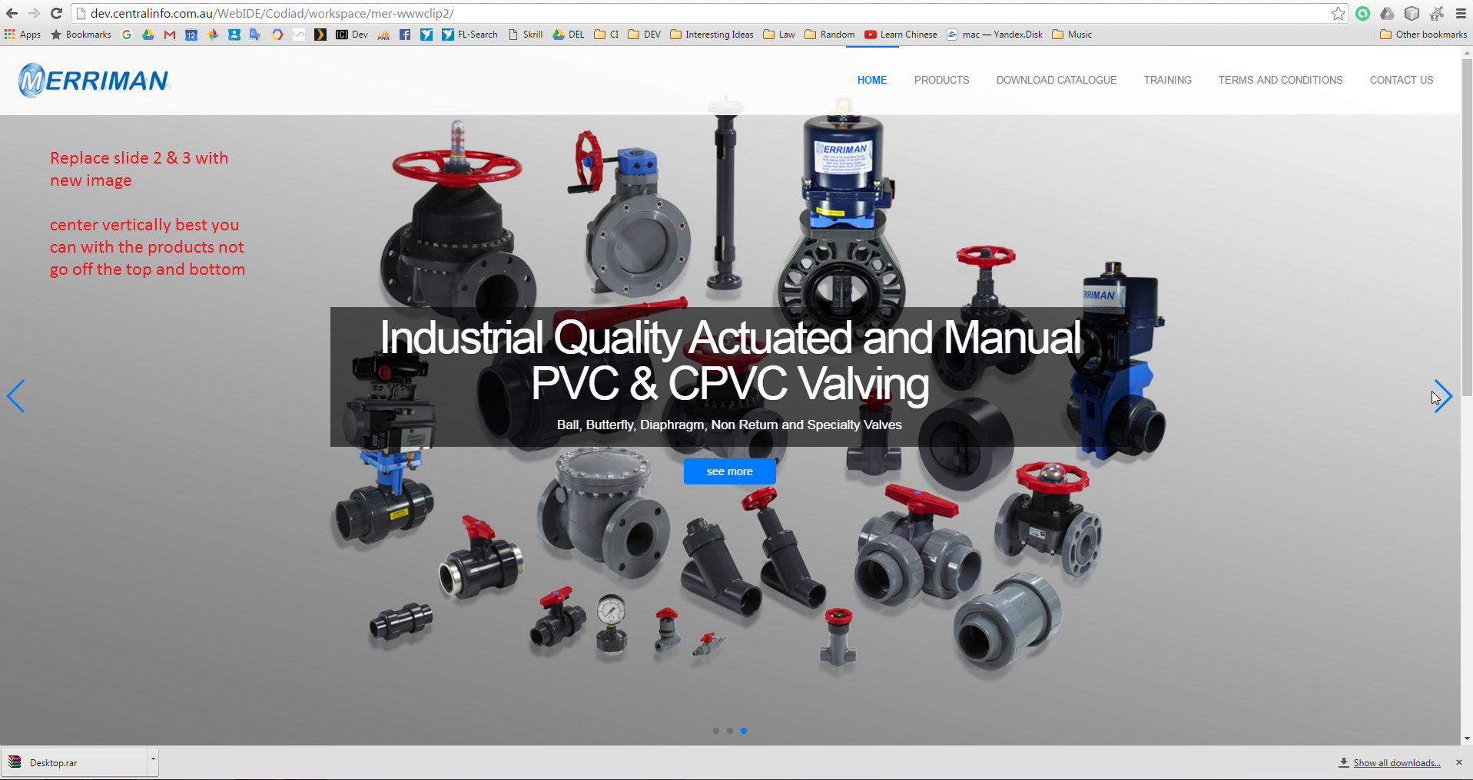

**4. Programming Logic**

N/A

**5. Database**

N/A

**6. Changes to Commit ( Developer to Complete section 6a, 6b, 6c)**

This section is to help the Project Manager update the test site and live site. Please fill in the below area’s 6a, 6b and 6c, this is to inform the Project Manager as to what changes were made and needed to add update the live site

**6a. Files / Folders to add to live site**

Please add to the below table a list of files or folders that the Project Manager will need to upload to the live site.

|  |  |  |  |
| --- | --- | --- | --- |
| Folder Name: |  | | |
| File Name | File Name | File Name | File Name |
|  |  |  |  |
|  |  |  |  |
|  |  |  |  |

|  |  |  |  |
| --- | --- | --- | --- |
| Folder Name: |  | | |
| File Name | File Name | File Name | File Name |
|  |  |  |  |
|  |  |  |  |
|  |  |  |  |

|  |  |  |  |
| --- | --- | --- | --- |
| Folder Name: |  | | |
| File Name | File Name | File Name | File Name |
|  |  |  |  |
|  |  |  |  |
|  |  |  |  |

**6b. Database Changes to add to live site**

Please add below any db changes or db script code the Project Manager will need to add to the live site database

**6c. Developer notes / instructions for Project Manager**

Please add here any instructions for the Project Manager to follow for updating the live site

Eg. 1. Please run db script

2. Please insert new data to db

3. Then update files in live site

**END**